SURFACE AREA
OCR Tuesday 5 November 2019 – Morning (Calculator) Foundation Tier
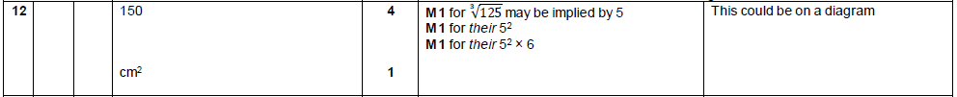

AQA Tuesday 19 May 2020 – Morning (Non-Calculator) Foundation Tier

